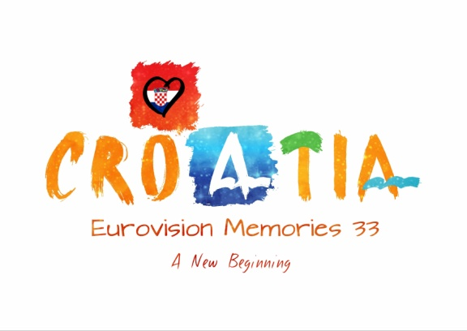
EUROVISION MEMORIES 33 SONG CONTEST

The “Eurovision Memories 33 Song Contest” is a Song Contest organized and presented by EM Corporation 2013. The contest will start on 20 July 2013 and will end in August 2013. The submission period has a total of seven days (20 July 2013 – 27 July 2013). Former participants must confirm their place until 23 July. Countries that don’t confirm participation until 23 July will be officially declared FREE.
All general rules from the website are valid this edition and can be found here: http://www.eurovisionmemories.com/rules.html
The SEMIFINALS
EM 33 will have two Semifinals, both containing 22 countries and songs. Top 10 countries from each semifinal that will get the highest points will qualify to the Grand Final.
The Second Chance Round
Every Semifinal will have a Second Chance round. Places 11th, 12th, 13th and 14th from each semifinal will fight in the SC round and the top 2 countries that will get the highest score will advance to the Second and last phase of the Second Chance Round. A total of 4 songs (2 from each semifinal SC round) will fight for two tickets available for the Grand Final.
The voting will be LIVE (10 minutes only) and people can vote on the website or by SMS.

