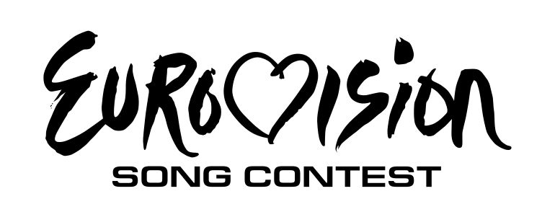

The Contest in General
- The country with the highest points wins an edition.
- The participant needs to choose the host city, presenters, venue. If you want, you can add to a logo and slogan, if not, the webmaster will do it.
- Cheating/not accepting the rules will lead to disqualification of at least 2 editions. If the cheating/not accepting of the rules is recidivist , it will lead to disqualification from the whole contest.
- If the Administrator considers that Your country has advantages from other countries (for example, your friend is playing too and he always gives you 12 points) has the right to disqualify both you and your friend(s).
Countries
- You can only use a country which has the status of FREE. Look for those countries at Free Countries in this website.
- You can only participate for ONE country.
- You are free to change your country every edition. If you win, you must stay with the same in the next edition.
- If you want to participate a country which is not on this website, ask the webmaster. Then, we will both decide what the possibilities are.
- At the moment, we're slowing expand our list of countries to the ones actives in EBU. If the number of players grows, there will a possibility to use more international countries in Asia, North/South America, Africa and Oceania.
- Neighbor Rule: Some countries can borrow singers/groups from neighboring countries. You can see the possibilities here.
Songs
- Songs may not be longer then 6 minutes and not shorter then 2 minutes and 30 seconds.
- The songs may sing in any language.
- The songs need to be submitted in a YouTube URL link.
- Official Eurovision Song Contest songs are NOT allowed, but songs of National Selections are allowed to use.
- National Finals for Eurovision Memories can be organized. Contact the webmaster for it.
- It is strongly recommended that your song should have a video clip, this could easily raise you a lot of points. Without a video clip, you're automatically out of "Best Video Clip" prize.
- Covers are just allowed if the song that is being covered comes from the same country as it's representing.
Covers of American songs or Eurovision songs are not allowed!
Artist
- The artist needs to have the same nationality as the country it will represent. When it comes to a group or duo, at least 50% of the group/duo needs to be from the country they'll represent.
- Artists that already passed away are allowed in this contest.
- The artist/group can represent twice time in a row in this competition.
- If the participant uses an artist/group another one cannot be using that artist/group for its country.
- The artist can have double citizenship.
Voting System
- The voting system is like the official Eurovision Song Contest (1-2-3-4-5-6-7-8-10-12)
- You can send your votes to eurovisionmemories1@gmail.com.
- Everyone needs to vote. If you don't vote in semi-finals, you can't proceed to the final, but you still can vote for the final. If you don't vote at the final, you will be disqualified from the competition for, at least, two editions.
- Send your votes according to the dates on the current edition page.
- Once you have sent your votes via Email you cannot modify them again.
- Always try to vote on time, else your votes will not count.
- If you cannot vote on time, please let the webmaster know this at least 72 hours before the deadline.
- We won't accept 'artificial' votes. As a competitor you need to analyze all the songs and give points correctly!
- We just want one winner, so if the result ends up with a tie where two or more countries has got the same amount of points we will start counting how many votes each country received, if there is still a tie we will start counting the amount of 12's, 10's etc. If it's the same result after that we will make a re-vote between these countries and the country with the most votes will be named the winner.
The Semifinals
- If you didn't reached top 3 in the last edition, you will be automatically participating in a Semifinal according to the draw.
- To determine the order we will use random.org.
- When the numbers of participants are more than 20 countries there will be one semi-final, if there are more than 25, there will be 2 semi-finals.
- During the competition of a semifinal, according to the number of participants, in order, the most-voted countries goes directly to the final, while others in the middle of the table go to the Second Chance Show. In the Second Chance show we're using a 50/50 system were 50% of the results comes from the poll-voters while the other 50% comes from a "secret jury". The secret jury contains of three members from the contest who isn't in the Second Chance, the members of the secret jury is changing each edition.
- The webmaster will decide the number of qualifications, according to the number of participants.
Music Awards
- Each edition the finalists competes for three different music awards, the "Best Video Clip" award, the "Jury Award" and the "Best Voice" award. The "Best Video Clip" award and the "Best Voice" award is being decided by all the visitors on the site by a poll-voting while the "Jury Award" will be decided by the EM Organizers which will analyze all the songs based on a special criteria.
- The nominated songs for “Best Video Clip” and “Best Voice” are being determined by the Eurovision Memories administration.
- Only the songs in the final can be selected for the prizes.
The "Second Chance"
- The second chance allows countries that didn't qualify in the semifinals to get another chance.
- A poll will be opened for the public to decide the top 3 qualifiers
- A jury will be used and the votes will be combined to find out the best top 3 qualifiers. The jury is picked randomly, in case they don't answer in time the EM Team will play the jury role.
